1. Write a program to display the size of all types of variables using the sizeof operator.

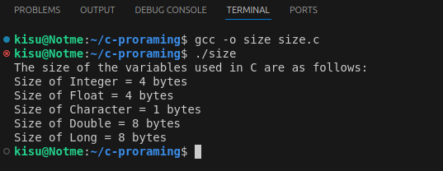
Output :
2. Write a program to compute the area of a circle by taking the radius as input (take π as a constant)

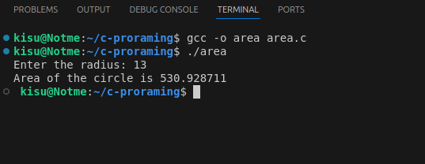
Output :
3, write a source code to take a length in feet and convert it into inches

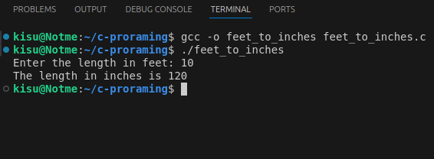
Output :
4. Write a program that accepts marks of 5 students from the user and calculates the total marks and percentage obtained

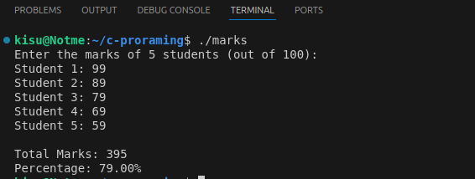

Output :
5. Write a program to find if a given number is divisible by 5 and 3 but not by 10.

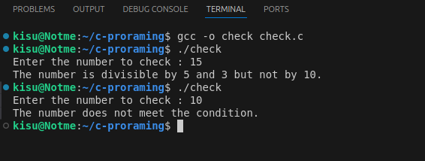
Output :
6. Write a program to show basic arithmetic operations.

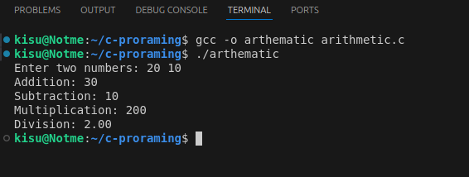
Output :
7. Write a program to take a number from the user and identify if it is negative, positive, or zero.

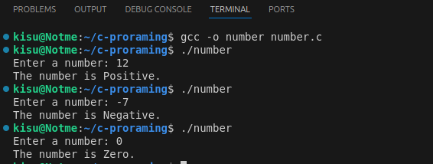
Output :

